**Solace CLI --> show session :: What is the default unit of the Timeout?**

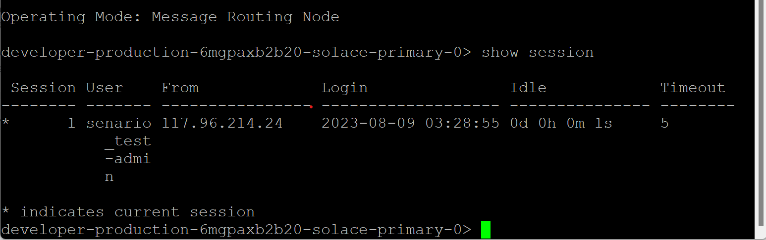

The default unit of Timeout is in **Minutes**